Q.1-> what is inline function?

Ans- when a function is being called multiple time in the program it increase execution time so inline function is used to reduce compile time and increase code efficiency.

It is not used in the case of recursion.

inline int product(int a, int b){

return a*b;}

Q.2-> why use class instead of structure?

Classess and Structure are almost similar but in structure we can not hide data which means that everything is public and can be accessed easily. Another drawback of structure is that we ca not add function.

Q-3-> what is friend function?

Friend function are those functions that have the right to access the private data member of class even though they are not defined inside the class.

Q4-> what is constructor?

A constructor is used to initialise the data of the object. it is special member functions with the same as the class. Its automatically invoked whenever the object is created.

* declared in the public section of the class
* do not have return types

Q5->What is destructor?

A destructor is a type of function which is called when the object is destroyed , it never takes any argument nor does it return any value.

Q.6-> what is oops?

It is the programming style which is associated with the concept of class and object . it **improves code readability and reusability**.

Q.7-> what is class?

It is a user defined data types, which holds its own data member and member function which can be accessed and used by creating an instance of that class.

example a car as a class that has characteristics like , seats, brakes, etc. And its behavior is mobility. But we can say **Honda City**  is an ‘object’ that belongs to the class **‘car’**.

Q8->what is object?

an Object is an instance of the class.

When a class is defined no memory is allocated but when object is created memory is allocated.

Q.9-> what is access specifier?

Aceess specifier defines how the members of the class can be accessed.

* public - members are accessible from outside the class
* private - members cannot be accessed (or viewed) from outside the class
* protected - members cannot be accessed from outside the class, however, they can be accessed in inherited classes

Q.10-> what is inheritance?

The capability of a class to derive properties and characteristics from another class is called inheritance.

* subclass/derived class /child class(new class)

*superclass/base class/parent class(exist class)

example:class bus, car,truck is inheritated from class vehicle because the some properties are same in all three like fuel amount , capacity , apply brakes.

syntAX: class <derived_class_name> : <access-specifier> <base_class_name>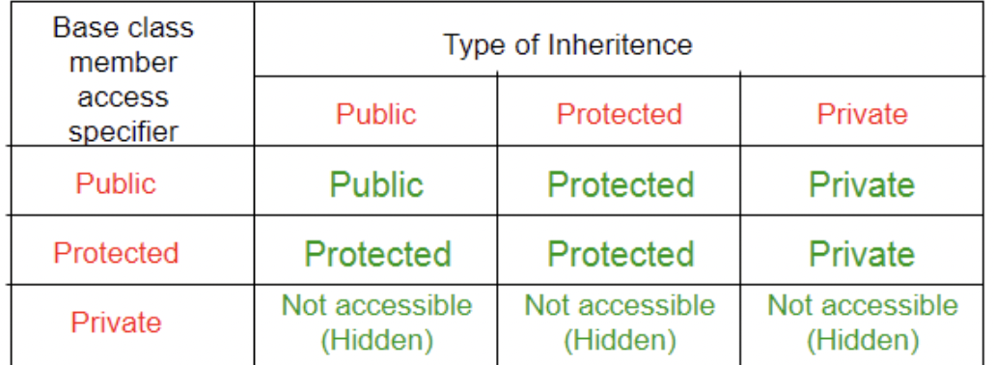

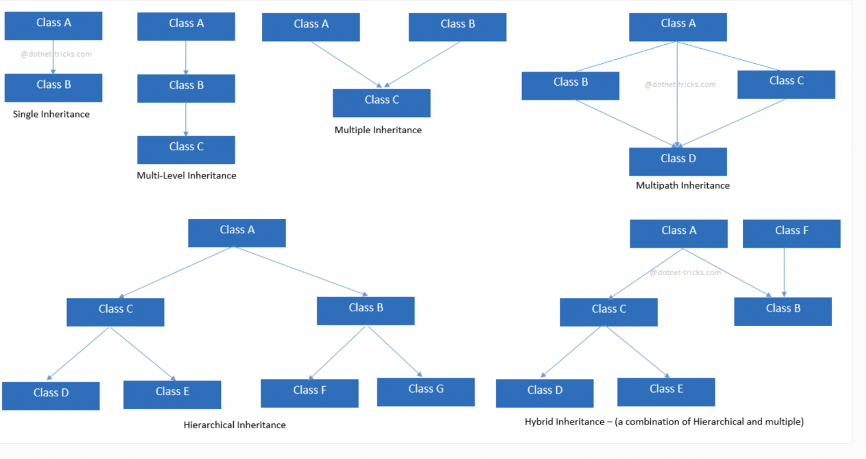

Q.11->what is polymorphism?

Sir/madam, polymorphism is the ability of a message to be displayed in more than one form.

example Like a man at the same time is a father, a husband and an employee. So the same person exhibits different behavior in different situations.

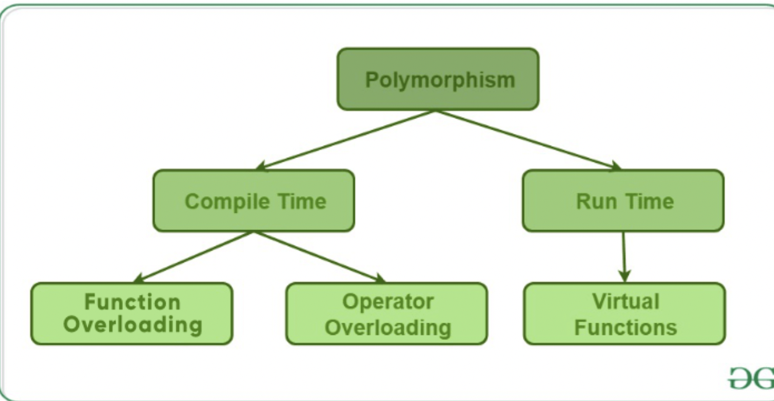

Q.12-> what is abstraction?

Abstraction means displaying only essential information and hiding the details.

Header file used is math.h

 example of a man driving a car. The man only knows that pressing the accelerators will increase the speed of car or applying brakes will stop the car but he does not know about how on pressing accelerator the speed is actually increasing,

Q.13-> what is Encapsulation?

In oops, encapsulation is defined as binding together the data and function that manipulate them.

example When you log into your email accounts such as Gmail, Yahoo Mail2, there is a lot of internal processes taking place in the backend and you have no control over it.

Q.14-> what is function overloading?

It is the concept where two or more function name can have same name but different parameter.

Ex- Add(double a, double b)

Q.15->what is function overriding?

When a derived class or child class defines a functions that is already defined in the base class or parent class that is called function overriding.

Q.16-> what is virtual function?

A virtual function is a member function which is declared with a virtual keyboard in the base class and redeclared in derived class.

Q.17->what is pointer?

A pointer is a variable that stores the memory address of an object.

Null pointer-: A null pointer is a pointer which points nothing.

Void pointer:- void pointers are pointers that point to a value that has no type.

Dangling pointer:- A pointer pointing to a memory location that has been deleted (or freed) is called dangling pointer.

Function pointer:- the function pointer is a pointer used to point functions. It is basically used to store the address of a function.

This pointer:- The this pointer is a pointer accessible only within the nonstatic member functions of a class , struct , or union type. It points to the object for which the member function is called.

Wild Pointer: The pointer which has not initialised to anything (not even null ).

What is Array: An array is collection of data items stored at contigious memory location. It stores same type of data together.

Operation: Insertion, Traversal, Deletion, Searching, Sorting, updating.

What is linked list:- Linked list a type of Data structure that include a series of connected nodes. Where Each node stores the Data and address of the next variable.

Types: Singly, Doubly, circular.

Operations: Insertion, Deletion, Searching, Sorting, And Merging.

Queue: A queue is a important data structure in programming. A queue follow the fifo method and it open at the both of ends.

Types: Simple Queue, Priority Queue, Circular Queue, and Doubly ended or Dequeue.

Operations: Enqueue()-process of adding or storing an element to the end of the queue.

Dequeue: The process of the removing an element from the front of the queue.

Peek: used to get the most front element without removing it.

Initialize: it is used to create a empty queue.

Isfull: its check wheather Queue is full or not.

Isempty: used to check wheather queue is empty or not.

What is stack: Stack is a linear data structure which follows a particular order in which the operations are performed. The order may be LIFO(Last In First Out) or FILO(First In Last Out).

Example: Wearing removing Bangels.

Operations: Push, pop , Peek , isempty.

What is Tree?

A tree is a kind of data structure that is used to represent the data in hierarchical form.

What is Binary Tree?

A binary tree is a tree data structure where each node has up to two child nodes, creating the branches of the tree.

What is binary search tree?

Binary search tree is a type of tree where the value of left node must be smaller than the parent node, and the value of right node must be greater than the parent node. This rule is applied recursively to the left and right subtrees of the root.

What is balanced tree?

A balanced binary tree is defined as a binary tree in which the height of the left and right subtree of any node differ by not more than 1.

What is Avl Tree?

AVL tree is a self-balancing Binary Search Tree (BST) where the difference between heights of left and right subtrees cannot be more than one for all nodes.

what is join in dbms:

A join clause is used to combine Rows from two or more tables based on a related between them.

Type: Inner Join:- It is a type of join which return records that have matching value in both table.,

Right join:- It is a type of join which return the records of right table and matched value of left table.

Left join: It is a type of join which return the value of left table and matching records of right table.

full join: It is a kind of join which return complete records of left and right of the table.

What is database: A database is the collection of data that is organized which is also called structured data.

Types: Relational Database

Distributed Database.

Cloud Database.

NoSql.

What is Acid?

To maintain the integrity of the data there are four properties described in the database management system which is called as acid concept.

Atomocity:- Either All or None.(ex-bhim/phonepe)

Consistency: Before the transaction start and after the transaction complete sum of money remains same.

Isolation: When we try to convert parralel sechdule into serial schdule that is called Isolation.

Durability: Whatever change you perform in database must be permanent that operation is called durability of dbms.

Normalization: Normalization is the process of organizing data in a database. It is used to reduce the redunency from a relation or set of relation.

1NF: It should not have multivalued attribute.

2NF: It must be in 1NF and No partial dependency.

3NF: Must follow 2NF but No transitative dependency+No non prime determine non prime.

BCNF(boycee codd)- Must followed 3NF and LHS must be candidate key or super key. It is the stronger value of 3NF.

4NF: Must have in BCNF+ No multilevel dependency.

5NF: Must have in 4NF and lossless decomposition.

Constraints: Constraints is used to specify the rule of the data in the table.

1. Unique: Ensure the value which is present into the table must be different example Emp id.
2. Not Null: Ensure that the column should not have empty exam- EmpId.
3. Primary Key: Ensure that the column should be not null + unique. Exam: EmpId.
4. Foreign Key(Referential): Prevent action that would destroy links between table.
5. Check: ensure that the value which is in column must satisfy a specific condition.
6. Default: Set a default variable when no value is satisfied.
7. Candidate key: The role of a candidate key is to identify a table row or column uniquely.

What is sql:

It stands for structured query language which is used to deal with structured data that means those types of data which is stored in form of table.

Sql Command:

1.DDL(Data definition Language): Create, Alter, Drop, Truncate, Rename.

2.DML(Data Manipulation Language): Insert, delete, Update.

3.DQL(Data Query Language): Select.

4.DCL(Data Control Language): Grant, Revoke.

5.TCL(Transaction Control Language): Commit, Rollback, Savepoints.

What is BFS?

The **Breadth First Search**  is an algorithm for traversing or searching tree or graph data structures. It explores all the nodes at the present depth before moving on to the nodes at the next depth level.

What is DFS?

The **Depth First Search** is an algorithm for traversing or searching tree or graph data structures which uses the idea of backtracking. It explores all the nodes by going forward if possible or uses backtracking.

What is dynamic Programming?

Dynamic Programming is mainly an optimization over plain [recursion](https://www.geeksforgeeks.org/recursion/). Wherever we see a recursive solution that has repeated calls for same inputs, we can optimize it using Dynamic Programming.

What is Greedy Algorithm?

A greedy algorithm is an approach for solving a problem by selecting the best option available at the moment. It doesn't worry whether the current best result will bring the overall optimal result.

What is ER model?

ER model stands for an Entity-Relationship model. It is a high-level data model. This model is used to define the data elements and relationship for a specified system.

Reverse a String using Two pointer Approach

function reverseString(str) {

let left = 0;

let right = str.length - 1;

while (left < right) {

const tempStart = str[left];

const tempEnd = str[right];

str[left] = tempEnd;

str[right] = tempStart;

left++;

right--;

}

}

Reverse an array with two pointer Appproach

void rvereseArray(int[] arr) {

start = 0

end = arr.length - 1

while (start < end) {

// swap arr[start] and arr[end]

int temp = arr[start]

arr[start] = arr[end]

arr[end] = temp

start = start + 1

end = end - 1

}

}

.....................................................................

.

|  |  |  |
| --- | --- | --- |
| Variable Scope->Local variables:Local variables are declared inside the braces of any function and can be assessed only from there.->Global variables:Global variables are declared outside any function and can be accessed from anywhere | Data Types Data types define the type of data that a variable can hold;  categorized into three groups:   * **Built-in:**Int,Float,Char,Double,Boolean * **User-defined- Struct,union ,enum** * **Derived-array ,pointer,function.** |  |
| Reserved keywords are those keywords that are used by the language itself, which is why these keywords are not available for re-definition or overloading | Screenshot 2022-08-04 at 12.03.14 PMOperators are used for producing output by performing various types of calculations on two or more inputs. |  |
| Structures The structure is a user-defined data type. Structures are used to combine different types of data types, | Unions are similar to structures but they provide better memory management then structures.  We can only use 1 variable at a time otherwise the compiler will give us a garbage value |  |
| Enums type is a special data type that enables for a variable to be a set of predefined constants | Functions We break the code into small pieces and make functions of that code. Functions help us to reuse the code easily. |  |
| The function prototype is the template of the function which tells the details of the function e.g(name, parameters) to the compiler.  int sum(int a, int b){  // Formal Parameters a and b will be taking values from actual parameters num1 and num2.  int c = a+b;  return c;} | Call by value is a method in C++ to pass the values to the function arguments. In case of call by value the copies of actual parameters are sent to the formal parameter, which means that if we change the values inside the function that will not affect the actual values. |  |
| A call by the pointer is a method in C++ to pass the values to the function arguments. In the case of call by pointer, the address of actual parameters is sent to the formal parameter, which means that if we change the values inside the function that will affect the actual values.  void swapPointer(int* a, int* b) | Call by reference is a method in C++ to pass the values to the function arguments. In the case of call by reference, the reference of actual parameters is sent to the formal parameter, which means that if we change the values inside the function that will affect the actual values  void swapReferenceVar(int &a, int &b) |  |
| When a static data member is created, there is only a single copy of the data member which is shared between all the objects of the class. |  |  |
|  |  |  |
|  |  |  |
|  |  |  |

## **Data Structure:**

A data structure is a storage that is used to store and organize data. It is a way of arranging data on a computer so that it can be accessed and updated efficiently.

## Types of Data Structure

Linear data structure:In linear data structures, the elements are arranged in sequence one after the other

Non-linear data structure:elements in non-linear data structures are not in any sequence. Instead they are arranged in a hierarchical manner where one element will be connected to one or more elements.

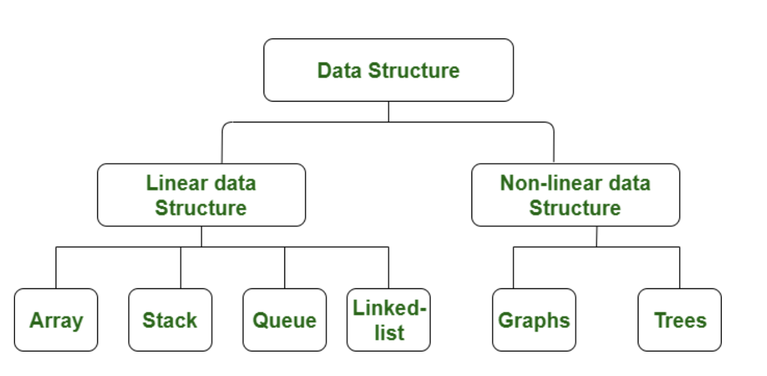

Asymptotic notations are the mathematical notations used to describe the running time of an algorithm when the input tends towards a particular value or a limiting value.

There are mainly three asymptotic notations:

* Big-O notation
* Omega notation
* Theta notation

## Big-O Notation (O-notation)

Big-O notation represents the upper bound of the running time of an algorithm. Thus, it gives the **worst-case complexity** of an algorithm.

## Omega Notation (Ω-notation)

Omega notation represents the lower bound of the running time of an algorithm. Thus, it provides the **best case complexity** of an algorithm.

## Theta Notation (Θ-notation)

Theta notation encloses the function from above and below. Since it represents the upper and the lower bound of the running time of an algorithm, it is used for `1analyzing the **average-case** complexity of an algorithm.

ARRAY

An array is a collection of items stored at contiguous memory locations. The idea is to store multiple items of the same type together.

Drawback

Static(size can not be change

homogenous(same data type )

The deletion and insertion operations in arrays are very difficult to implement as they store data in contiguous memory locations.

Array VS Linkedlist

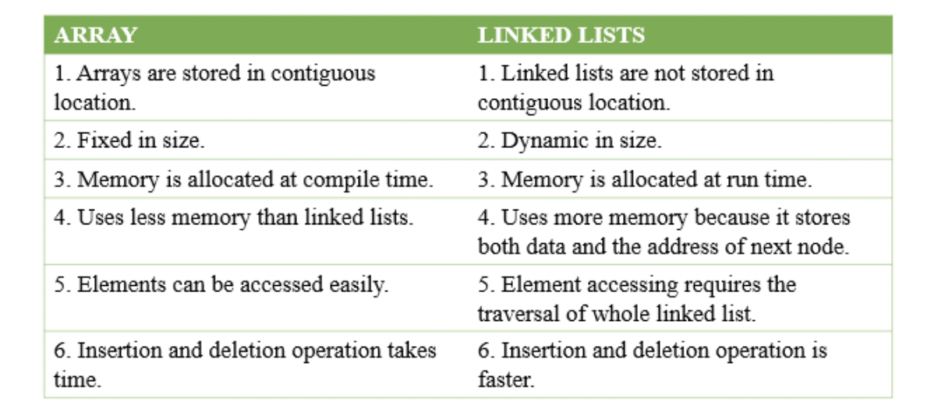

SEARCHING ALGORITHMS:Searching Algorithms are designed to check for an element or retrieve an element from any data structure where it is stored.

Two Types :

sequential search -example linear search

interval search -example binary search

In Linear search, we search an element or value in a given array by traversing the array from the starting, till the desired element or value is found

**Binary Search** is a [searching algorithm](https://www.geeksforgeeks.org/searching-algorithms/) used in a sorted array by **repeatedly dividing the search interval in half**.

# Sorting Algorithm

|  |  |  |  |  |
| --- | --- | --- | --- | --- |
| Sorting Algorithm | Time Complexity - Best | Time Complexity - Worst | Time Complexity - Average | Space Complexity |
| **Bubble Sort** | n | n2 | n2 | 1 |
| **Selection Sort** | n2 | n2 | n2 | 1 |
| **Insertion Sort** | n | n2 | n2 | 1 |
| **Merge Sort** | nlog n | nlog n | nlog n | n |
| **Quicksort** | nlog n | n2 | nlog n | log n |
| **Counting Sort** | n+k | n+k | n+k | max |
| **Radix Sort** | n+k | n+k | n+k | max |
| **Bucket Sort** | n+k | n2 | n | n+k |
| **Heap Sort** | nlog n | nlog n | nlog n | 1 |
| **Shell Sort** | nlog n | n2 | nlog n | 1 |

**Bubble sort** is [a sorting algorithm](https://www.programiz.com/dsa/sorting-algorithm) that compares two adjacent elements and swaps them until they are in the intended order.

|  |  |
| --- | --- |
| **Time Complexity** |  |
| s | O(n) |
| Worst | O(n2) |
| Average | O(n2) |

Selection sort is [a sorting algorithm](https://www.programiz.com/dsa/sorting-algorithm) that selects the smallest element from an unsorted list in each iteration and places that element at the beginning of the unsorted list.

|  |  |
| --- | --- |
| **Time Complexity** |  |
| Best | O(n2) |
| Worst | O(n2) |
| Average | O(n2) |

Insertion sort is [a sorting algorithm](https://www.programiz.com/dsa/sorting-algorithm) that places an unsorted element at its suitable place in each iteration.

|  |  |
| --- | --- |
| **Time Complexity** |  |
| Best | O(n) |
| Worst | O(n2) |
| Average | O(n2) |

Merge Sort is one of the most popular [sorting algorithms](https://www.programiz.com/dsa/sorting-algorithm) that is based on the principle of [Divide and Conquer Algorithm](https://www.programiz.com/dsa/divide-and-conquer).

**Divide and Conquer** technique, we divide a problem into subproblems. When the solution to each subproblem is ready, we 'combine' the results from the subproblems to solve the main problem.

|  |  |
| --- | --- |
| **Time Complexity** |  |
| Best | O(n*log n) |
| Worst | O(n*log n) |
| Average | O(n*log n) |

**QuickSort**is a[Divide and Conquer algorithm](https://www.geeksforgeeks.org/divide-and-conquer-algorithm-introduction/). It picks an element as a pivot and partitions the given array around the picked pivot.

|  |  |
| --- | --- |
| **Time Complexity** |  |
| Best | O(n*log n) |
| Worst | O(n2) |
| Average | O(n*log n) |